September 27, 2026
Attendance: Offering:
Sunday School: 49 September 27: $5388
Worship Hour: 78

Upcoming Events

October 18: 4-6 p.m. Fun Fall Event/ Pumpkin Carving
Powhatan Mennonite Church

3540 Old Buckingham Rd., P.O. Box 220
Powhatan, VA 23139, 804-598-0240

Secretary: Sheila Hughbanks, Wed. 10 a.m. to 12:p.m.
Pastor: John Engle, Mon.-Wed. & Friday
www.pmchurch.net

Spiritual Leadership Team
Pastor: John Engle, Head Elder: Dave Moyer
Elders: David Hart, Ronnie Moyer, Kevin Hertzler

Announcements
All bulletin announcements are due on Thursday, by 10:00 a.m.
Call 804-598-0240 or email, churchsecretary65@gmail.com

Announcements for the overhead on Sunday morning should be sent to
pmcmediateam@gmail.com by Friday, 7:00 p.m.

Powhatan Mennonite Church

3540 Old Buckingham Rd., P.O. Box 220
Powhatan, VA 23139, 804-598-0240

Secretary: Sheila Hughbanks, Wed. 10 a.m. to 12:p.m.
Pastor: John Engle, Mon.-Wed. & Friday
www.pmchurch.net

Spiritual Leadership Team
Pastor: John Engle, Head Elder: Dave Moyer
Elders: David Hart, Ronnie Moyer, Kevin Hertzler

Announcements
All bulletin announcements are due on Thursday, by 10:00 a.m.
Call 804-598-0240 or email, churchsecretary65@gmail.com

Announcements for the overhead on Sunday morning should be sent to
pmcmediateam@gmail.com by Friday, 7:00 p.m.

World
Communion
Sunday

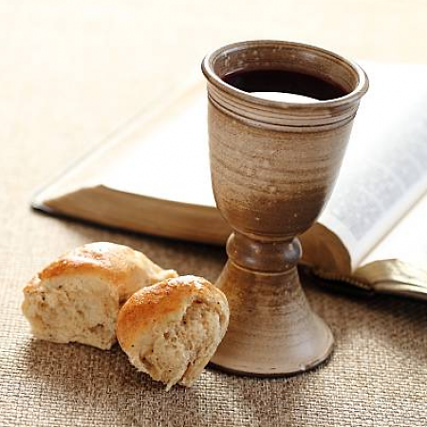

Announcements

The calendar for October is on the bulletin table.

Pastor John will be back in the office this week and will bring the message next Sunday.

Pumpkin carving! The Children’s Ministry is planning some fall fun for children and youth Sunday, October 18, 4 to 6 p.m. here at the church. Hotdogs and drinks will be provided. Families, please bring a side dish.

Prayer Time 9:30 a.m.
Sunday School 10:00 a.m.
Adult: “God Speaks Through His Church” Ed Ranck
Corporate Worship 11:00 a.m.
Welcome, Prayer David Hart
Worship Through Offerings
Worship in Song: Glen & Carol Landis
Scripture Reading: John 6: 28-35 David Hart
Message: “The Bread of Life” Rusty Yoder
Celebration of Communion
Prayer Partners: Ed & Doris Ranck
A warm welcome to our visitors.
Thank you for worshiping with us today.
Monday | Tuesday | Wednesday | Thursday | Friday | Saturday | Sunday
 | Lillian Hertzler  8 a.m. Men’s Bible Study  10 a.m. Titus 2 Fellowship | 7 p.m. SLT Meets |  |  | Rusty Yoder | John Engel Preaches

October 4, 2026

